**Full Title (bold, Calibri 16)**

**Presenting Author (Calibri 14)**, Co-Authors (Calibri 14)

Organization, City, Country (Calibri 12)

Contact@E-mail (Calibri 12)

**Abstract** (Calibri 12)

The abstract has a maximum length of one page, including figures and references. Please do not change the font sizes or the line spacing to allow for more content. Write the abstract in single-spaced text; you may use more than one paragraph. Greek letters, sub-, and superscripts should be formatted as such. Indicate references with sequential numbers within [square brackets].

**Figures**

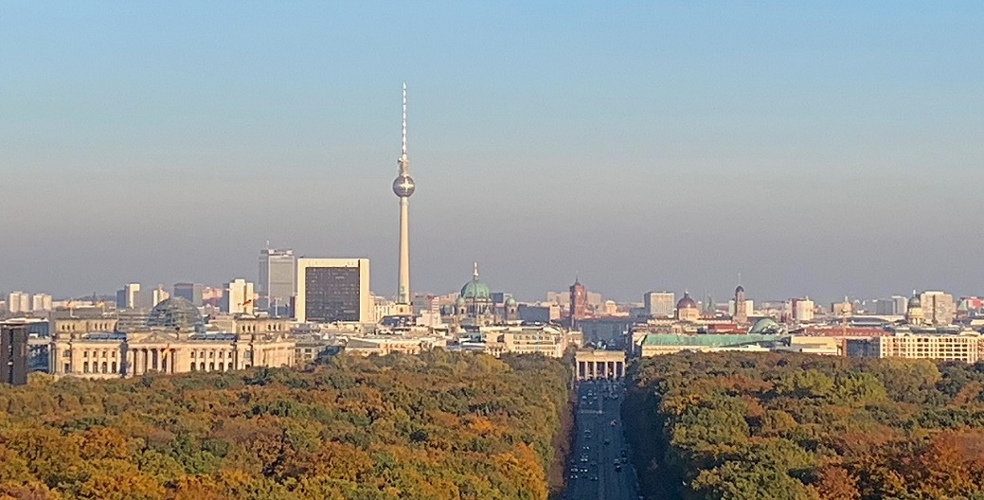

Figure 1: You may add as many figures as you want within the page limit. Please always provide a figure caption (Calibri 12). Exemplary image taken from Lear 21, Wikipedia.

**References**

1. Authors, Journal, Issue (**Year**) page (Calibri 12)
2. Authors, Journal, Issue (**Year**) page (Calibri 12)
3. Authors, Journal, Issue (**Year**) page (Calibri 12)
4. Authors, Journal, Issue (**Year**) page (Calibri 12)